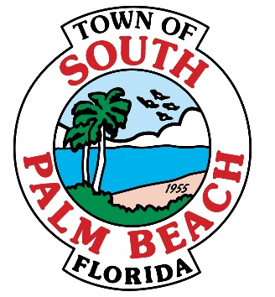

# **AGENDA**

# **SPECIAL TOWN COUNCIL- EXECUTIVE SESSION**

# **THURSDAY, OCTOBER 20, 2016 AT 1:00 P.M.**

1. **CALL TO ORDER AND ROLL CALL**

**Mayor Bernice Fischer _____**

**Vice-Mayor Dr. Joseph Flagello _____**

**Council Member Stella Jordan _____**

**Council Member Robert Gottlieb _____**

**Council Member Woodrow Gorbach _____**

1. **Motion to enter Executive Session**

* Pursuant to Section 447.605(1), Florida Statutes, a closed meeting shall be held on October 20, 2016, at 1:00 p.m. at Town Hall Chambers between the chief executive officer of the Town, his representatives, and the legislative body, the members of the Town Council, relative to collective bargaining. In accordance with Florida law, this meeting shall be closed as it is exempt from the provisions of Section 286.011.

1. **Motion to close Executive Session**
2. **Adjournment**