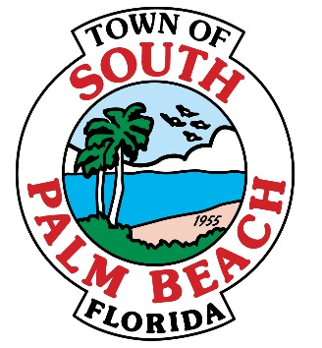

# **AGENDA**

# **REGULAR TOWN COUNCIL MEETING**

# **TUESDAY, January 24, 2017 AT 7:00 P.M.**

1. **CALL TO ORDER**
2. **ROLL CALL**

**Mayor Bernice Fischer _____**

**Vice-Mayor Dr. Joseph Flagello _____**

**Council Member Stella Jordan _____**

**Council Member Robert Gottlieb _____**

**Council Member Elvadianne Culbertson _____**

1. **PLEDGE OF ALLEGIANCE**
2. **APPROVAL OF AGENDA**
3. **APPROVAL OF MINUTES – TAB 1**
   * Regular Town Council Meeting- December 20, 2016
4. **CORRESPONDENCE AND COMMUNICATION**
5. **AWARDS/RECOGNITION**

* Recognition to Police Officers for services during Hurricane Matthew

1. **ORDINANCE- TAB 2**

* **Ordinance 286 (2nd Reading)-** An Ordinance of the Town Council of the Town of South Palm Beach, Florida, Amending Chapter 2. Administration. At Article II, Town Council, by repealing the Title of Article II and readopting it along with entirely new Section 2-26. To be entitled “Salaries- Town Council and Mayor.” to provide for increased compensation amounts for members of the Town Council, including the Mayor, pursuant to Town Charter §2-4.; providing for severability; providing for codification; and providing for an effective date.

1. **RESOLUTIONS- NONE**
2. **OTHER BUSINESS- TAB 3**

* Town Manager Evaluation Process

1. **FINANCIALS- TAB 4**

* December Unaudited Financial Statements

1. **REPORTS OF TOWN OFFICIALS**

* **Town Manager**
  + Welcome Packet- Presentation by Gigi Hortance**- TAB 5**
  + FY16 Audit
  + Chugs & Derelict Vessels on the beach
* **Police Department- TAB 6**
  + Activity Report for December 2016
* **Town Attorney**
* **Building Official- TAB 7**
  + Report on building permits issued through December 2016

1. **BOARD AND COMMITTEE REPORTS**
2. **MAYOR’S REPORT**
3. **REPORTS FROM MEMBERS OF COUNCIL**
4. **PUBLIC COMMENT**
5. **ADJOURNMENT**

* **Next Regular Council Meeting February 28, 2017 at 7:00 P.M.**

**IF A PERSON DECIDES TO APPEAL ANY DECISION MADE BY THE COUNCIL WITH RESPECT TO ANY MATTER CONSIDERED AT SUCH MEETING OR HEARING, HE/SHE WILL NEED A RECORD OF THE PROCEEDINGS, AND THAT FOR SUCH PURPOSE, HE/SHE MAY NEED TO ENSURE THAT A VERBATIM RECORD OF THE PROCEEDINGS IS MADE, WHICH RECORD INCLUDES THE TESTIMONY AND EVIDENCE UPON WHICH THE APPEAL IS TO BE BASED. PERSONS WHO NEED AN ACCOMMODATION IN ORDER TO PARTICIPATE IN THIS MEETING SHOULD CONTACT TOWN HALL AT (561) 588-8889 AT LEAST 3 BUSINESS DAYS PRIOR TO A COUNCIL MEETING OR PUBLIC HEARING IN ORDER TO REQUEST SUCH ASSISTANCE.**